About Department:
Mahatma Gandhi Sarvodaya Sangh's
Padmashri Manibhai Desai Mahavidyalay, Uruli Kanchan
Department of Computer Science and Computer Applications
(B.Sc. Computer Science and B.B.A. Computer Applications)

Objectives
The goals of our undergraduate programs (B.Sc. Computer Science, B.B.A. Computer Applications) are to:
(1) teach students how to use computers effectively, creatively, and intelligently;
(2) teach computer science as a multifaceted, humanistic discipline of problem solving;
(3) provide up-to-date curricula in the technical and scientific knowledge needed for the professional and academic goals of our students;
(4) teach students how to acquire new knowledge, independently, in a world that changes rapidly;
(5) provide students with experiential learning opportunities;
(6) educate an increasing number of undergraduates in computer science to meet the growing demands of the regional and national economy.

Vision
To create a conducive environment for skill-oriented education of high quality in the field of Computer Science and Information Technology. To develop the students' abilities to be able to compete in global technological society.

Mission
To share the knowledge in Computer Science and in interdisciplinary areas to benefit the students; to develop the students from rural area so that they can make careers in Information Technology; to educate students to be successful, ethical, and effective problem-solvers and life-long learners who will contribute positively to the economic well-being of our region and nation; prepare the students to tackle complex 21st Century challenges.

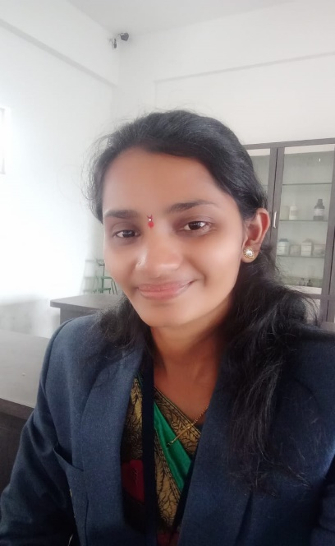
Staff Details
Name: Vaishali Mukinda Choudhari
Designation: Head of the Department (Computer Science)
Qualification: M.Sc. Comp. Sci.
Email ID: vaishalichoudhari43@gmail.com
Contact No: +91 9172183392
Experience(in Years): 10 Years
Expertise Area: Python, C# .Net, TCS

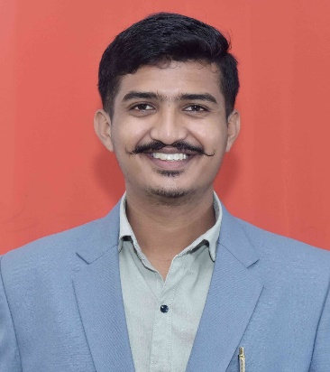
Name: Pratik Hanumant Adhav
Designation: Head of the Department (Computer Applications)
Qualification: M.Sc. Comp. Sci.
Email ID: adhavpratik77@gmail.com
Contact No: +91 74475 27531
Experience(in Years): 1.5 Years
Expertise Area: JAVA, PYTHON, Digital Marketing, CPP

Name: Bhosale Harshal Vijay
Designation: Assistant Professor
Qualification: M.Sc. Comp. Sci.
Email ID: harshalvbhosale9123@gmail.com
Contact No: +91 9011693567
Experience(in Years): 1.5 Years
Expertise Area: Data science, PYTHON

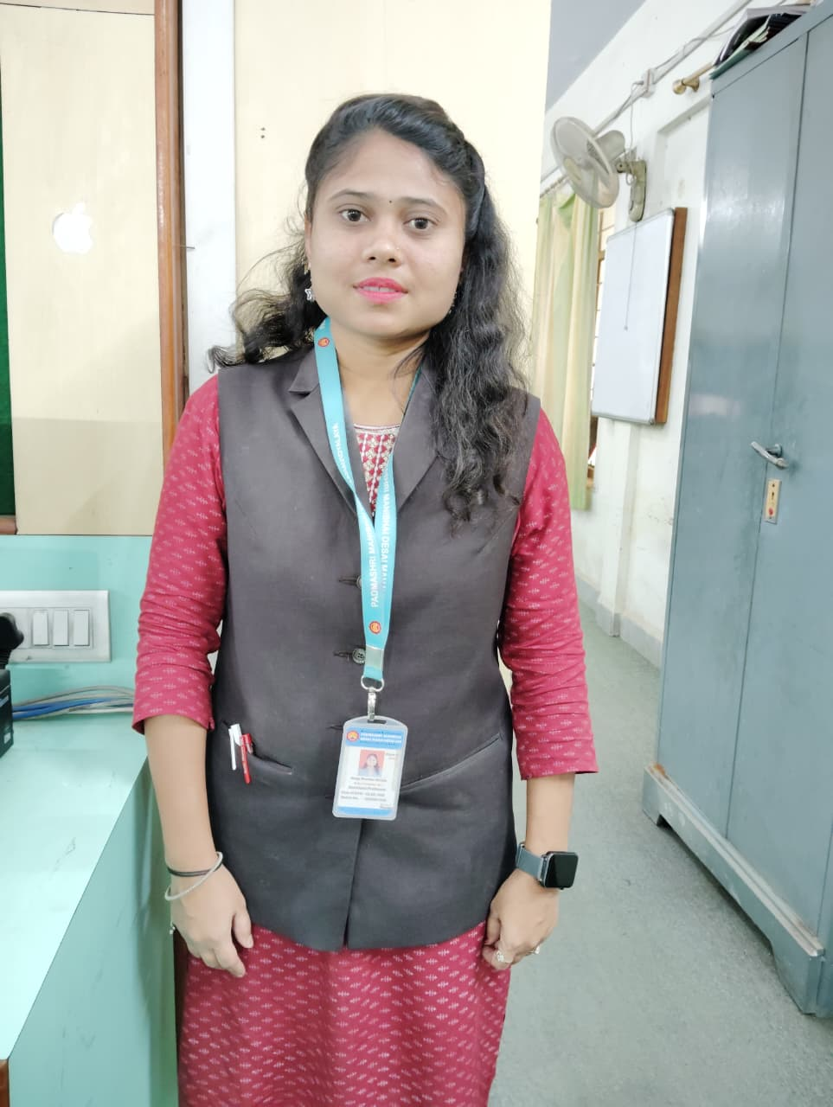
Name: Anuja Shankar Shinde
Designation: Assistant Professor
Qualification: M.Sc. Comp. Sci.
Email ID: shindeanu0506@gmail.com
Contact No: +91 7517996023
Experience(in Years): 1.5 Years
Expertise Area: Operating System, DBMS
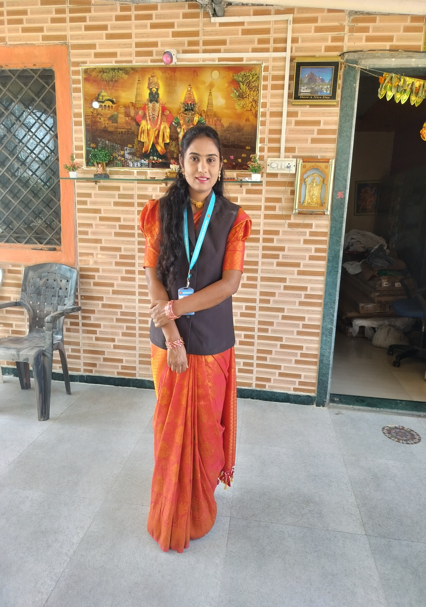
Name: Thorat Prajakta Balasaheb
Designation: Assistant Professor
Qualification: Electronics and Telecommunication Engineering
Email ID: prajakta8581@gmail.com
Contact No:7507748581
Experience(in Years): 2.5 years
Expertise Area: Electronics

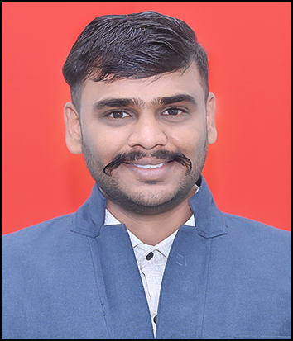
Name: Tilekar Gaurav Rajendra
Designation: Assistant Professor
Qualification: MCA
Email ID: gauravtilekar05@gmail.com
Contact No: 7040040659
Experience(in Years): 0.7 years
Expertise Area: Data Structure

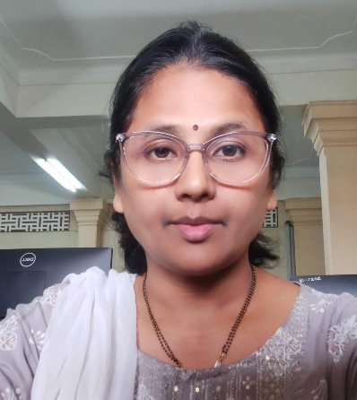
Name:Amruta Sameer Bapte
Designation: Assistant Professor
Qualification: MCA(Comp. Application)
Email ID: abapte@gmail.com
Contact No: 9420425226
Experience(in Years): 14 Years
Expertise Area: DBMS,PLSQL,CSS,Javascript, Web-Development

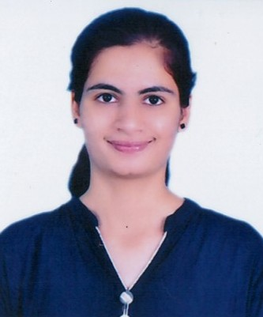
Name: Nagawade Manali Shankar
Designation: Assistant Professor
Qualification: MCA(Comp. Application)
Email ID: manalinagawade@gmail.com
Contact No: 7020865708
Experience(in Years): 0.7 Years
Expertise Area: C programming.

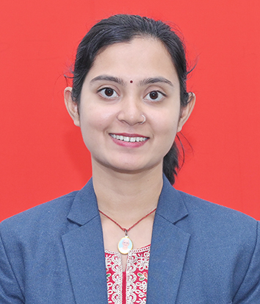
Name: Kumbhar Rutuja Pradip.
Designation: Assistant Professor
Qualification:MCA
Email ID:001rutuja@gmqil.com
Contact No:9370794159
Experience(in Years): 0.3 years
Expertise Area: Java

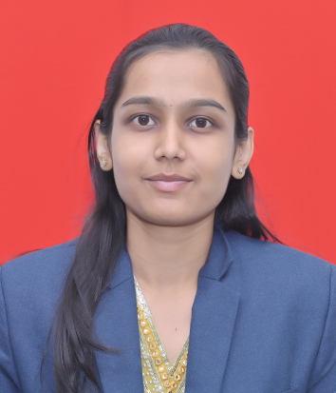
Name: Ketki Ashok Salunkhe
Designation: Assistant professor
Qualification: M.Sc. (Statistics)
Email ID: ketkisalunkhe2001@gmail.com
Contact No: 9763917674
Experience(in Years): 0.4 years
Expertise Area: Statistics, Mathematics


Name: Jagtap Bapu Uttareshwar
Designation: Lab Assistant
Qualification: B.A.CCNA
Email ID: manishjagtap7@gmail.com
Contact No: 9763989095
Experience(in Years): 16 years

Photos of infrastructure 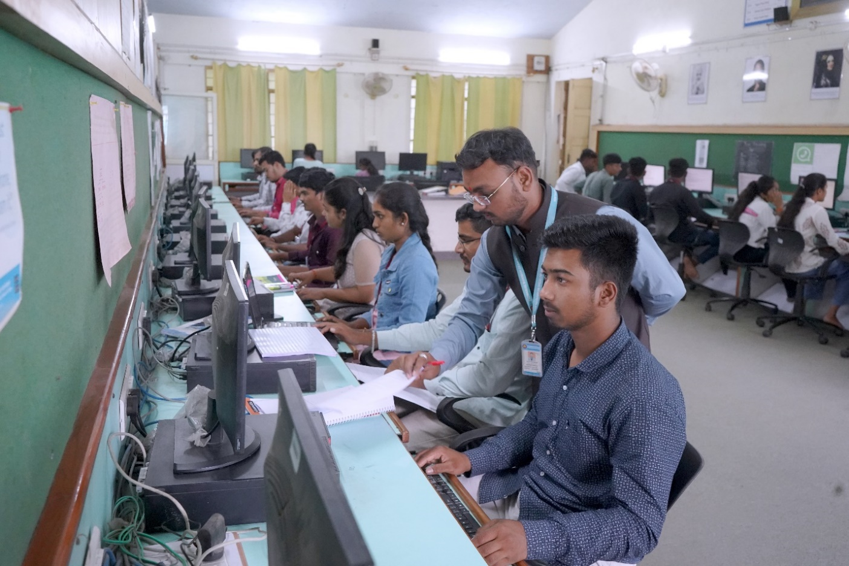 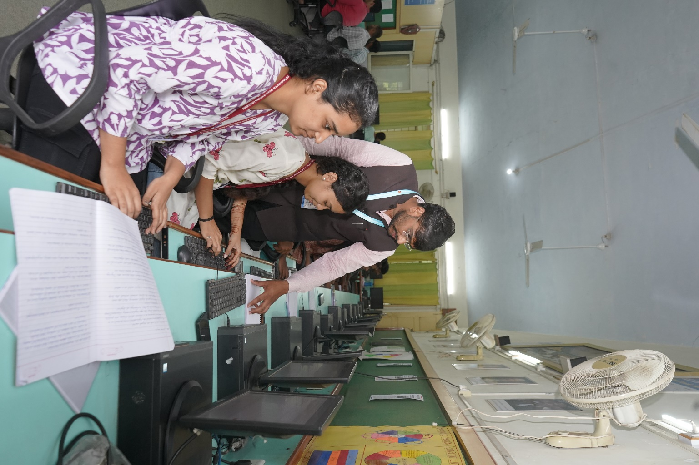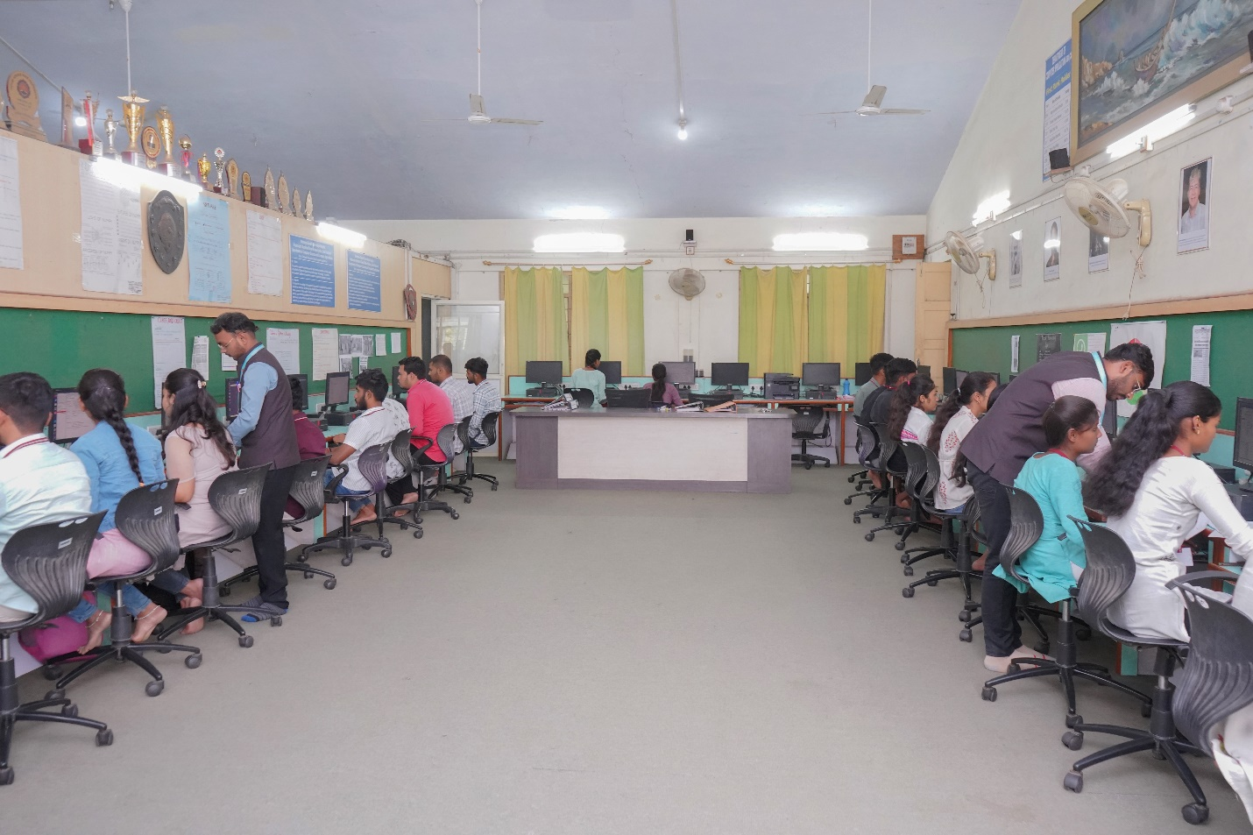
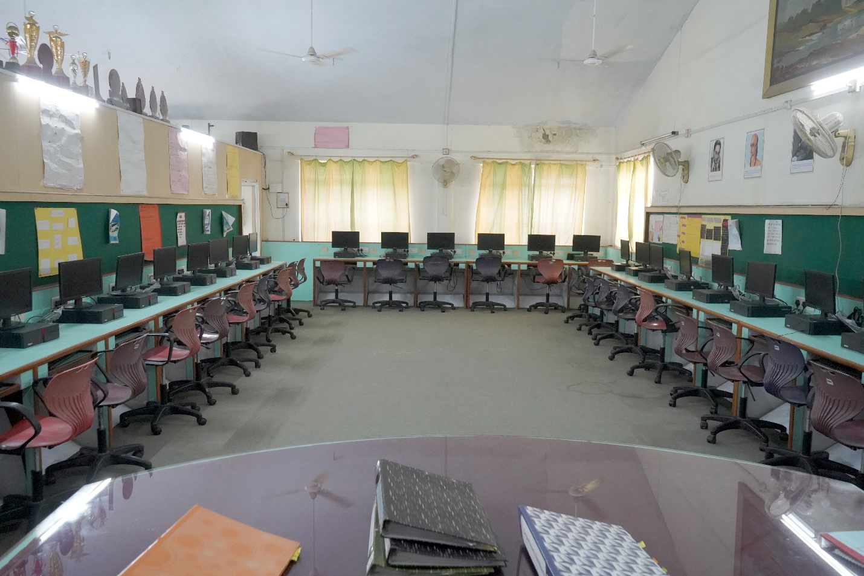
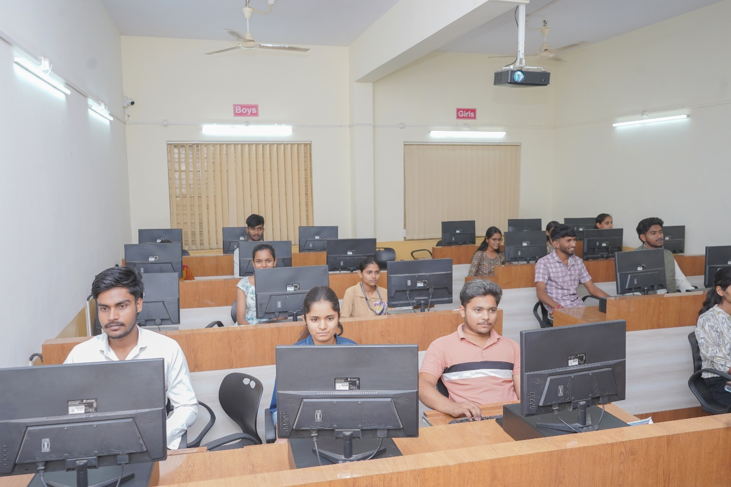
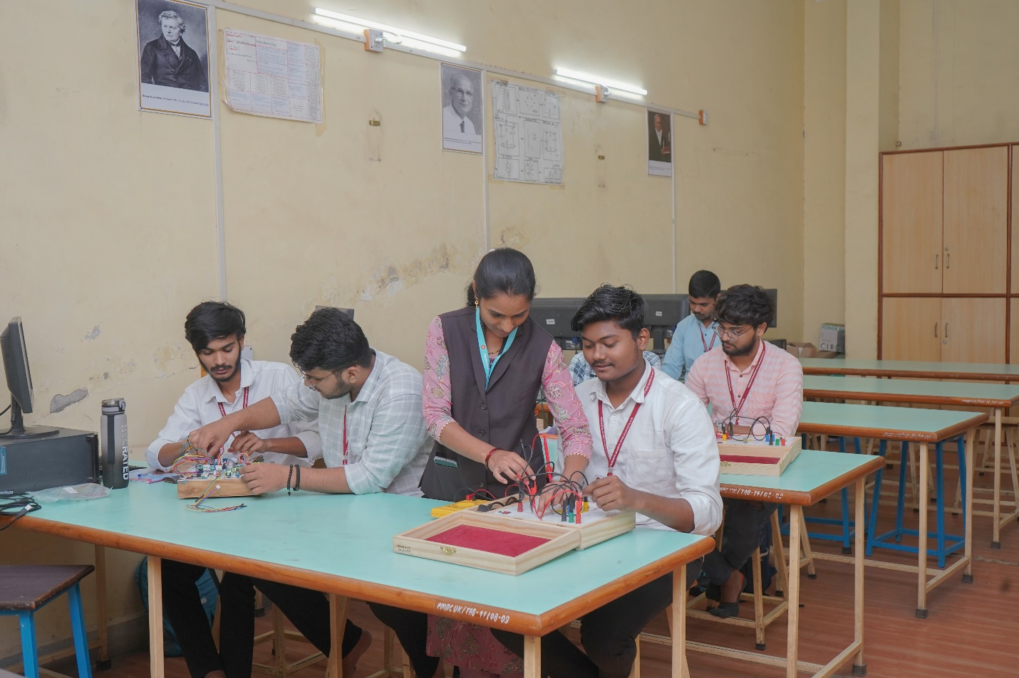
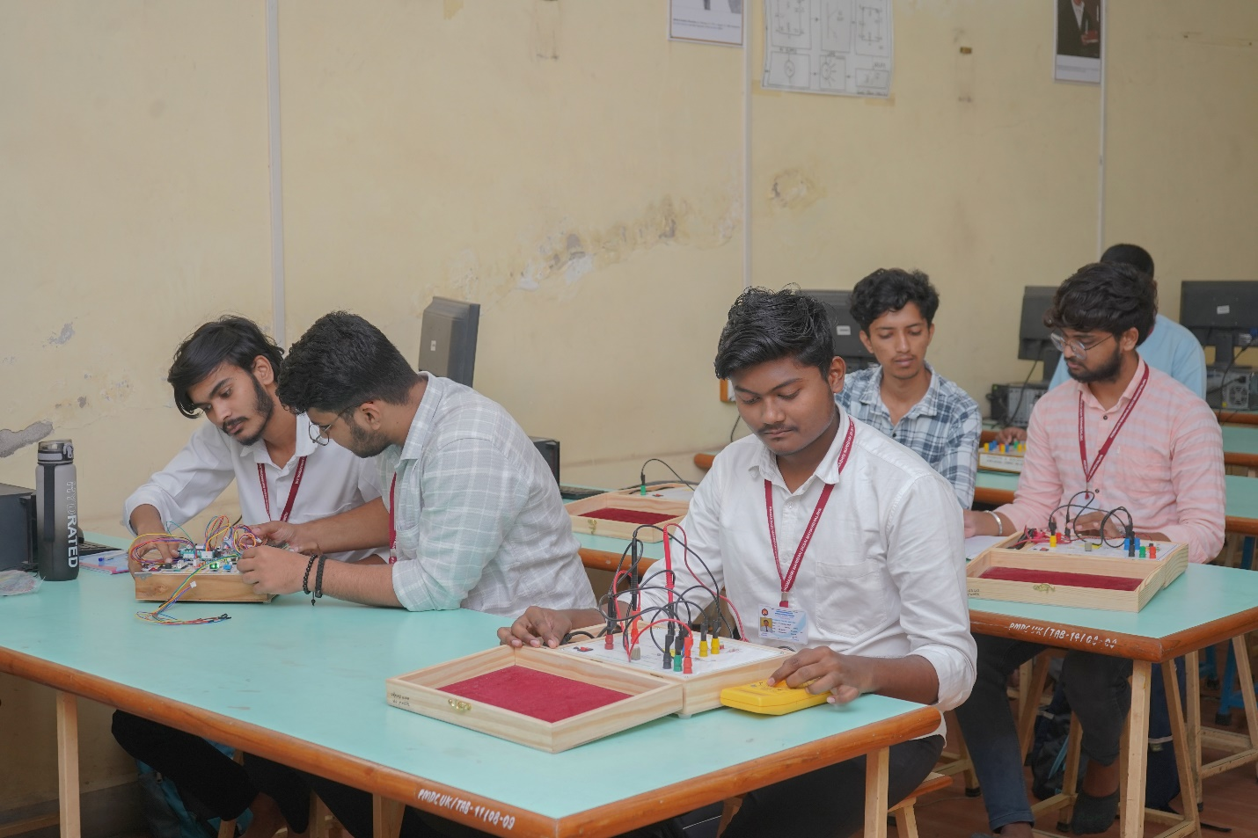
Other Photos: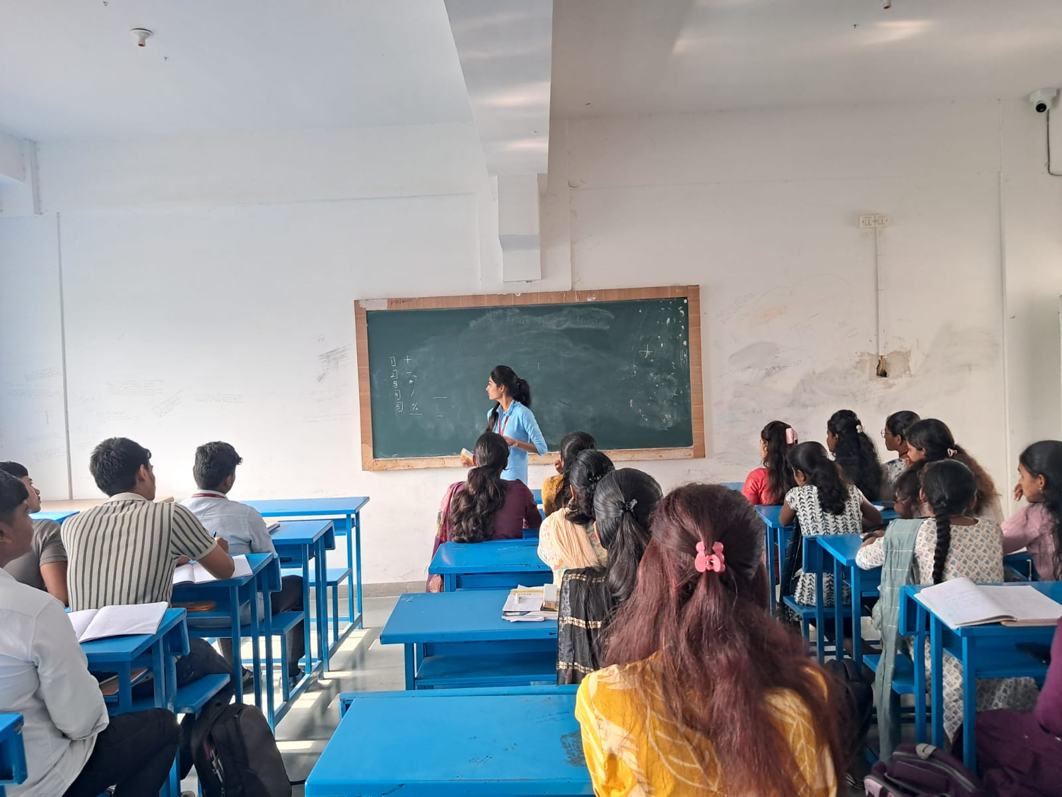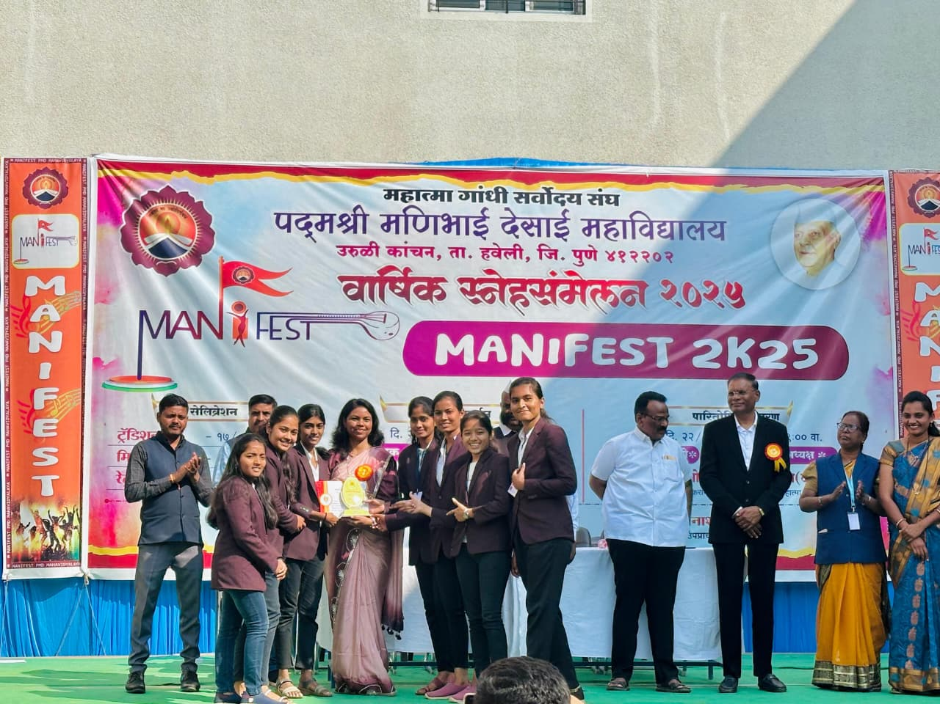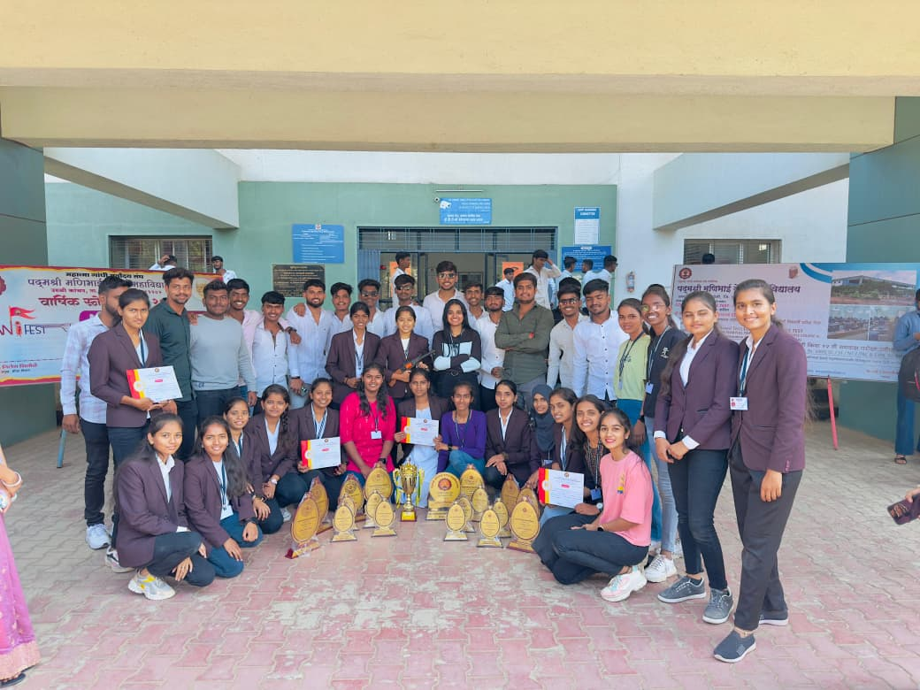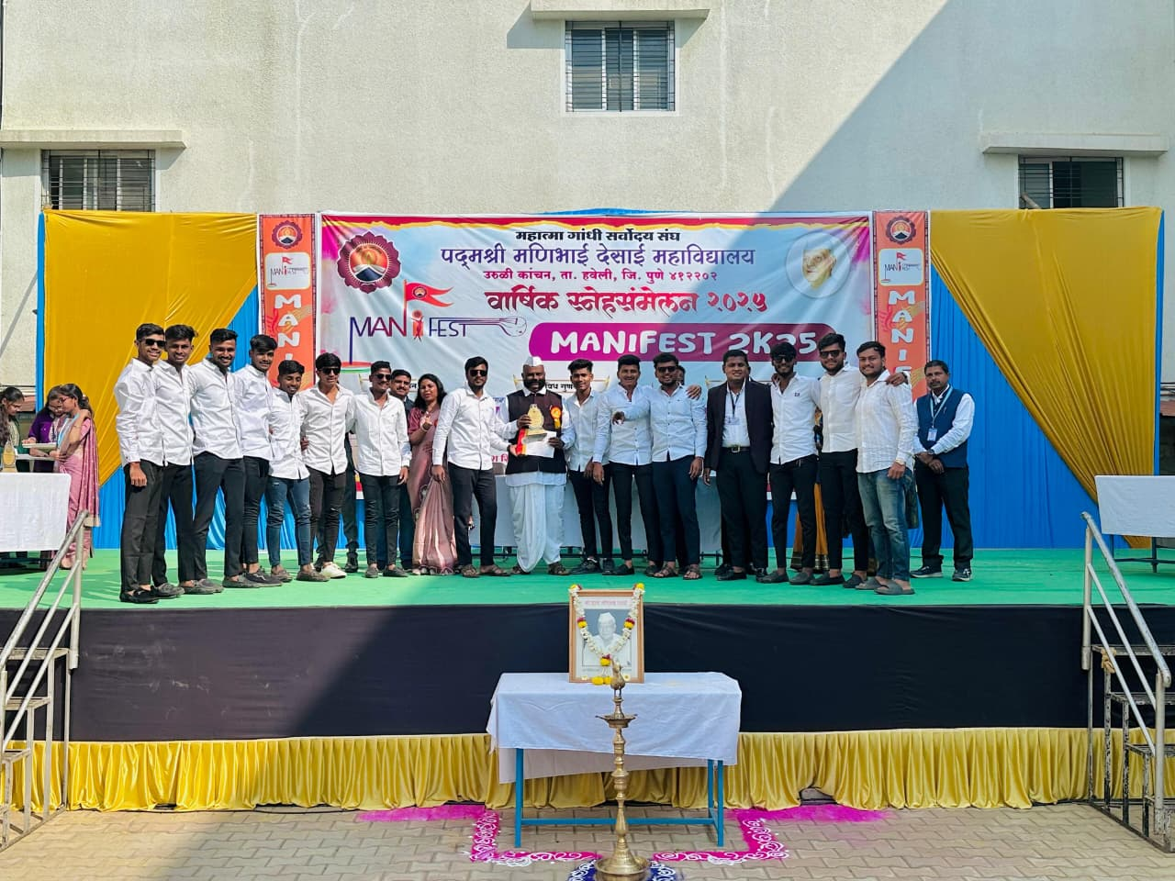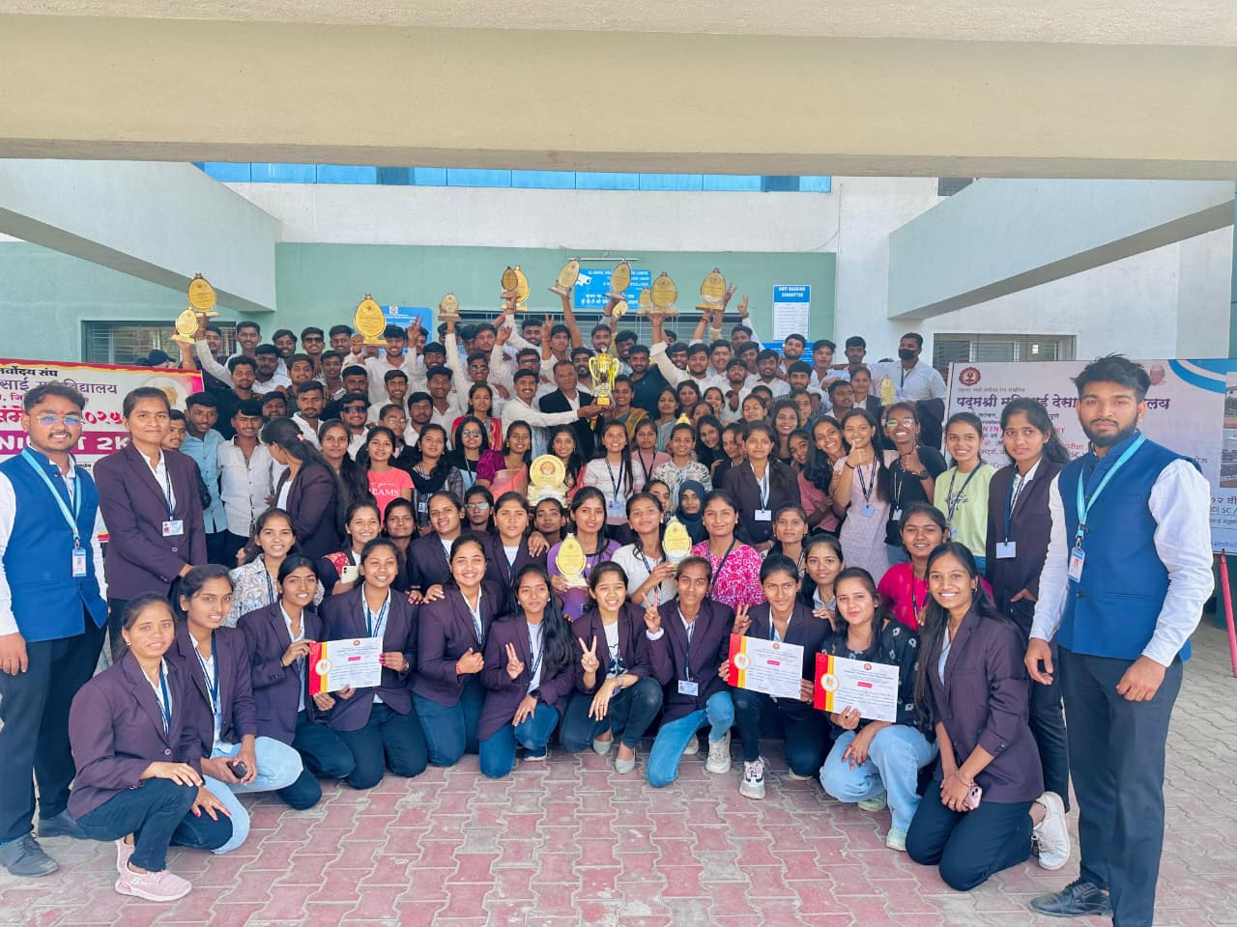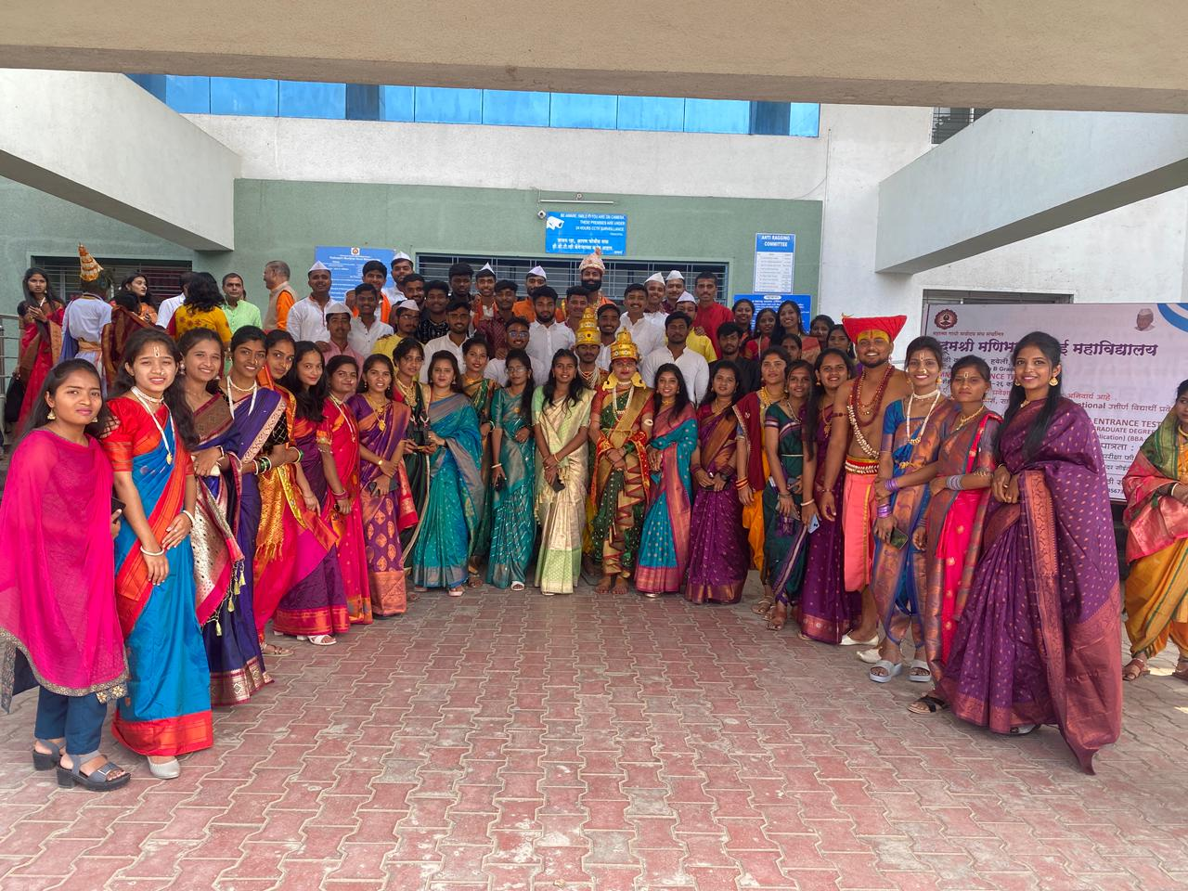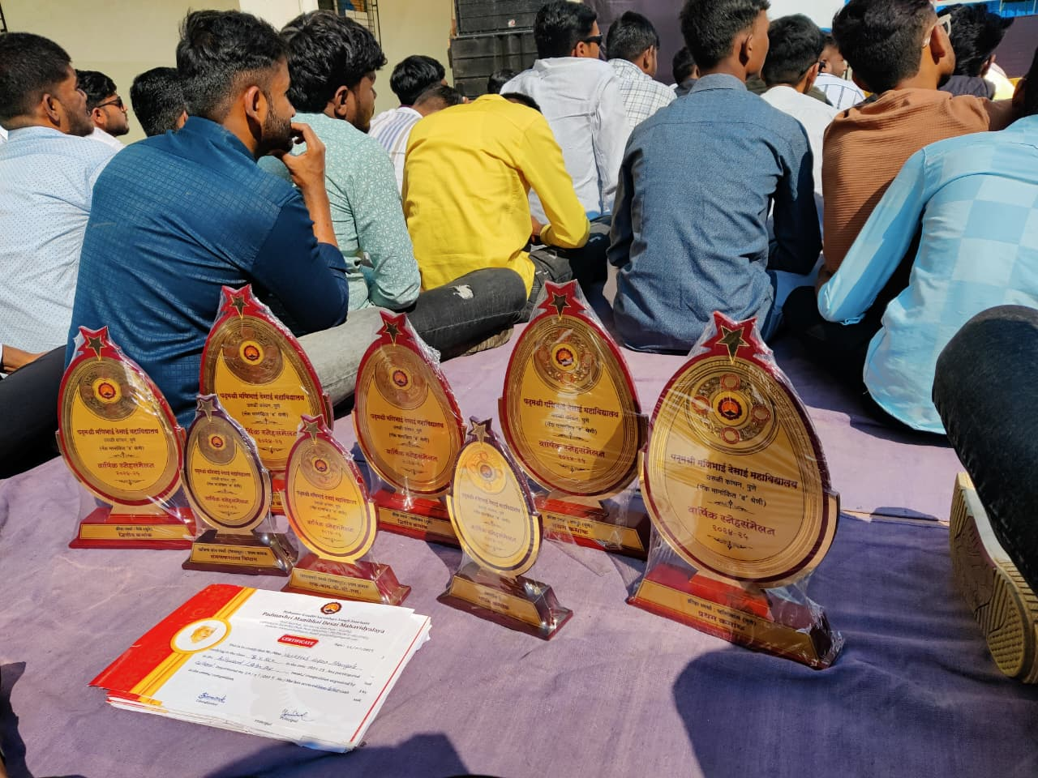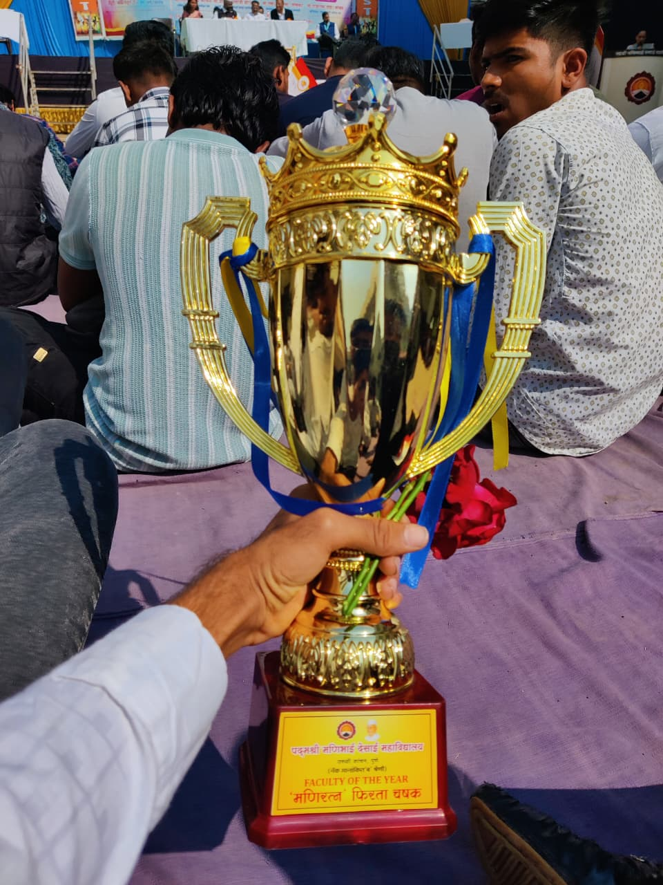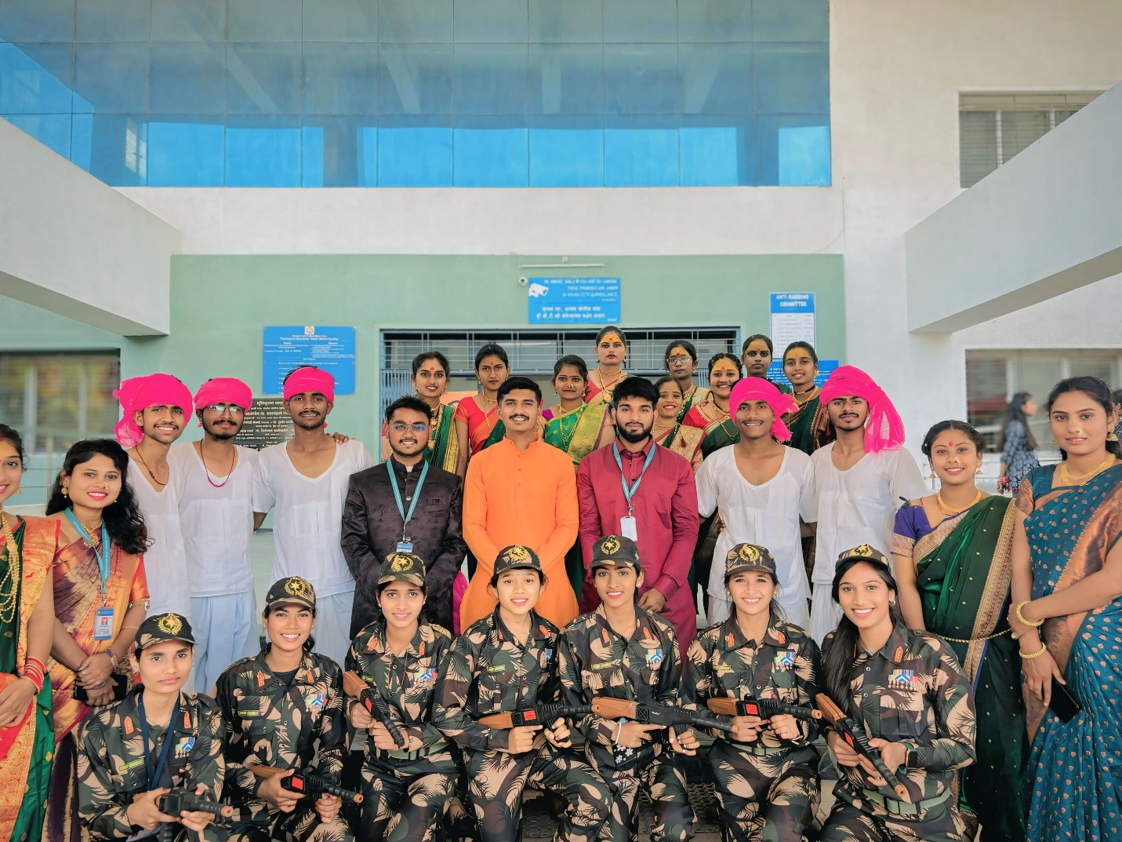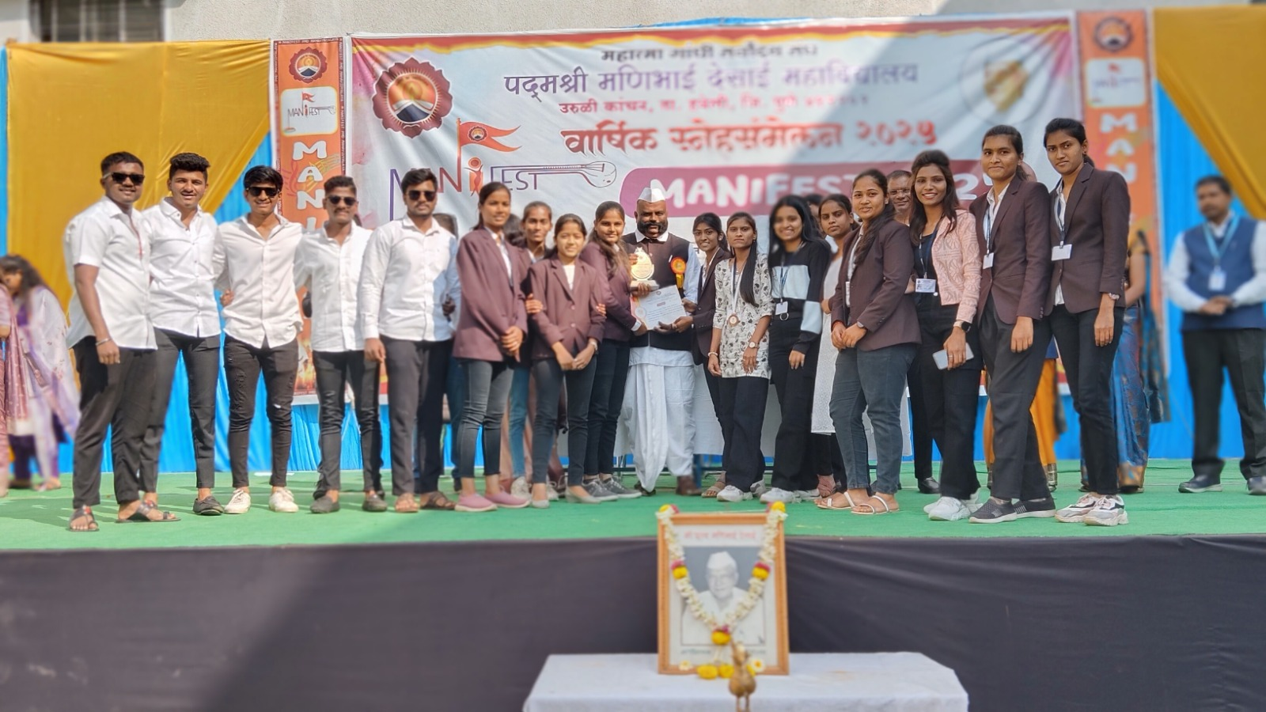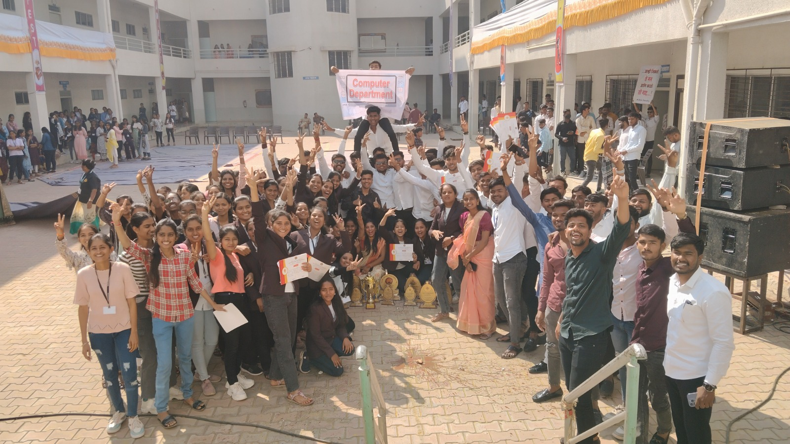

Research Papers
S. N. | Name of faculty | Workshop/ Seminar/ Conference | Level (Internation/ National/ State) | Activity (Participation/ Paper Presentation | Journal Name | Title of Paper
1 | Prof. Adhav P. H. | Conference | International | Participation | International Journal of Scientific Research in Engineering and Management (IJSREM) | Comparative Study of Java and Python Languages with Reference to Data Science
2 | Prof. Adhav P. H. | Conference | International | Presentation | International Research Journal of Modernization in Engineering Technology and Science (IRJMETS) | Evaluating the impact of compiler optimizations on program Performance: a comparative analysis of c, c++, and java
3 | Prof. Bhosale H. V. | Conference | International | Participation | International Journal of Multifaceted and Multilingual Studies | Comparative Study of Cloud Platforms for Data Science: Evaluate AWS, Google Cloud and Azure
4 | Prof. Choudhari V. M. | Conference | International | Participation | International Journal of Multifaceted and Multilingual Studies | evaluating data visualization tools - tablue,power BI and Excel
5 | Prof. Shinde A. S. | Conference | International | Participation | International Journal of Multifaceted and Multilingual Studies | Artificial Intelligence and Machine Learning
6 | Prof. Thorat P. B. | Conference | International | Participation | International Journal of Multifaceted and Multilingual Studies | Automated Air Pollution Detection and Control in Vehicles

Course Structure
Sr.No. | Course Name | Course Details | Pattern | Syllabus
1 | B.Sc.(Computer Science) | Bachelors Degree in Computer Science | NEP Pattern | FYBSc(CS) NEP Detailed Final Revised Syllabus 2024.docx
2 | B.B.A.(Computer Applications) | Bachelors Degree in Computer Applications | NEP Pattern | FYBBA-CA-Revised Syllabus_11112024.pdf

Key Highlights & Best Practices
- Class Guardian and Mentor-Mentee System:
A structured mentoring program to ensure personalized academic and emotional support to each student.
- Remedial and Bridge Courses:
Special sessions conducted for academically weaker students and non-IT background learners to strengthen foundational knowledge.
- Skill Enhancement Courses:
Add-on and certification courses in trending technologies such as Python, AI, Data Analytics, Cloud Computing, and Cybersecurity.
- Industry Collaboration:
Strategic MoUs with IT companies and training institutes to facilitate student internships, live projects, and placements.
- Guest Lectures and Industry Talks:
Regular sessions conducted by industry professionals to keep students updated with the latest trends and practices.

Teaching Pedagogy
Our department adopts a variety of innovative teaching methodologies to enhance student engagement and academic performance:
- Interactive Lectures & Group Discussions
- Flipped Classroom Approach using YouTube and Google Classroom
- Computer-Assisted Learning with hands-on software tools
- Field Visits & Industrial Exposure for real-world learning
- Assignments, Mini Projects, and Presentations to improve practical skills
- Expert Guidance & Aptitude Training for competitive readiness
- Online Assessments and ICT-based Teaching using Google Meet, PPTs, and Learning Management Systems (LMS)

ICT Integration in Teaching
The department is equipped with a modern computer lab, high-speed internet, LCD projectors, and ICT tools to support blended learning. Faculty members use:
- Google Classroom for assignment sharing and communication
- Video lectures for complex topic explanations
- WhatsApp groups for real-time student interaction and updates
- PPTs, e-notes, and quizzes for continuous engagement

Laboratory & Practical Work
- Dedicated practical sessions are an integral part of the BBA(CA) curriculum.
- Each session includes detailed explanations, demonstrations, and supervised hands-on practice.
- Additional lab hours are provided for students requiring extra support in programming and software tools.
- Real-time projects and coding challenges help enhance problem-solving abilities.

Assessment & Evaluation
- Examinations are conducted as per the university guidelines.
- Internal evaluations include two prelim exams, assignments, viva, and practical tests.
- Continuous assessments ensure regular academic tracking and timely intervention.
- Final year students undertake Industrial Training Projects to gain real-world exposure.

Co-Curricular and Extra-Curricular Activities
The department organizes various academic and personality development events throughout the year:
- Student Induction Program
- Poster and Essay Competitions
- Technical Workshops and Hands-on Training
- Awareness Campaigns on Cybersecurity and Digital Literacy
- Meditation, Yoga & Wellness Programs
- Guest Lectures on Industry Trends
- Workshops on Resume Building, Soft Skills & Interview Techniques

Experiential Learning Initiatives
- Industrial Visits to software companies, tech hubs, and startups.
- Business Fairs to develop entrepreneurial thinking and marketing strategies.
- Simulation Activities and role-playing exercises to instill business and IT skills.
- Live Projects guided by industry experts and faculty mentors.

Collaborative Learning & Industry Interface
To align academic knowledge with industry expectations, the department has entered into collaborations with reputed organizations:
- MoUs with Tech Companies for training, internships, and placements.
- Internship programs for third-year students to gain practical exposure.
- Industrial mentorship programs to provide guidance on career paths and latest tools.
- Guest sessions by professionals from software firms, startups, and business consultancies.

Training & Placement Support
- Dedicated Training and Placement Cell coordinates pre-placement training, resume preparation, and mock interviews.
- Tie-ups with recruitment agencies and software firms to ensure career opportunities for students.
- Alumni mentoring for guidance in higher studies and job readiness.

Student Achievements & Participation
- Students regularly participate and win accolades in coding competitions, paper presentations, business quizzes, and startup hackathons.
- Participation in social outreach programs and NSS activities reflects our commitment to holistic development.

